Science Fair Written Report
The written report is a summary of everything that you did to investigate your topic. The written report provides others with vital information on what your project is about as well as its effect on your understanding of the topic. The report has no minimum page requirement but should include ALL of the information listed below. This report provides you with the opportunity to think about all the aspects of your project and share your ideas with others. Here are some rules for your report:
- The report must be typed, 12 point Times New Roman or Arial, 1” margins
- Remember to put headings/titles on graphs/charts/tables.
- All photographs must have captions explaining their importance.
- Before you hand in your report make sure to reread, revise, and rewrite.
- Recheck any calculations, spelling, and grammar.
All written reports for a science fair project should include the following:
- Title Page: The first page in the report should include the title of the project as well as the name and grade of the student. **Should be on its own page**
- Introduction: This paragraph should include a sentence that grabs the reader’s attention, introduces the topic being discussed, describes WHY the topic was chosen, and sets the tone for the rest of the paper.
- Statement of Purpose: State the purpose of the project in the form of a question.
- Hypothesis- Hypothesis must be stated in an “If….Then…” format.
- Research: This is the part of the report that contains all of the background information that you collected about your topic. Any books or articles read from the Internet/journal, authorities on the topic that you talked to, or outside materials collected should be summarized in this section. This section should be written in your own words and NOT copied from your sources. You need to use at least 3 resources.
- Variables: You need to identify the variables in your experiment: independent variables, dependent variables, and controlled variables.
- Material: This is a list of all the materials and supplies used in the project. Quantities (amounts) of each material should also be indicated.
- Procedure: You will list and describe the steps you took to complete the project. Usually this is listed in a numbered sequence.
- Observation and Results/Data Collection: In this section, you will tell what you learned from the project. It is also IMPORTANT to include all graphs, charts, or pictures that help to show your results. Remember, an experiment must be run at least 3 times in order for the results to be considered valid!
- Conclusion: This is a brief statement explaining WHY your project turned out the way it did. You should explain why the events you observed occurred. Using the word “because” is a good way to turn an observation into a conclusion. Your conclusion should tell whether your hypothesis was proven or not proven. Also give the reason(s) why you chose to learn more about the subject and what you know now about the project that you didn’t know before you completed the project.
- Bibliography: The bibliography should list all of the resources the student used to carry out the project. Items should be listed in alphabetical order in a standard format. These websites are a great place to go to find the proper way of writing a bibliography: http://www.bibme.org/ and http://easybib.com.
The written report is worth over half of your Science Fair grade, so take your time and do it right!

Citing a website with an author

Structure:
Last, First M. “Article Title.”Website Title. Website Publisher, Date Month Year Published. Web. Date Month Year Accessed.
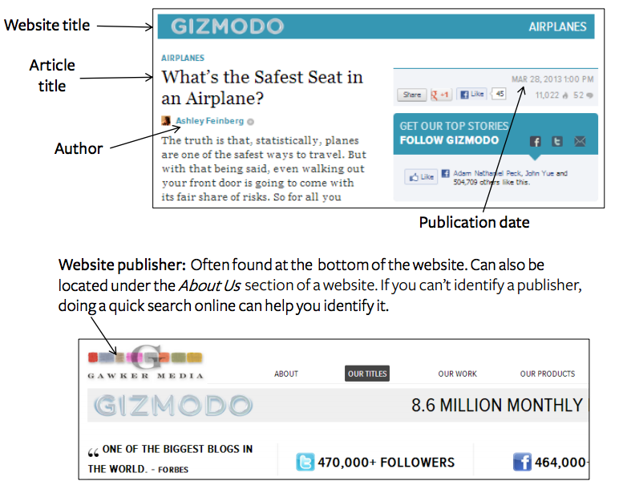
Date Accessed: This is the day that the article was found and read.
Example:
Feinberg, Ashley. “What’s the Safest Seat in an Airplane?” Gizmodo. Gawker Media, 28 Mar. 2013. Web. 30 Mar. 2013.

Citing a website with no author
Example:
“Website Article.” Website Title. Website Publisher, Date Month Year Published. Web. Date Month Year Accessed.
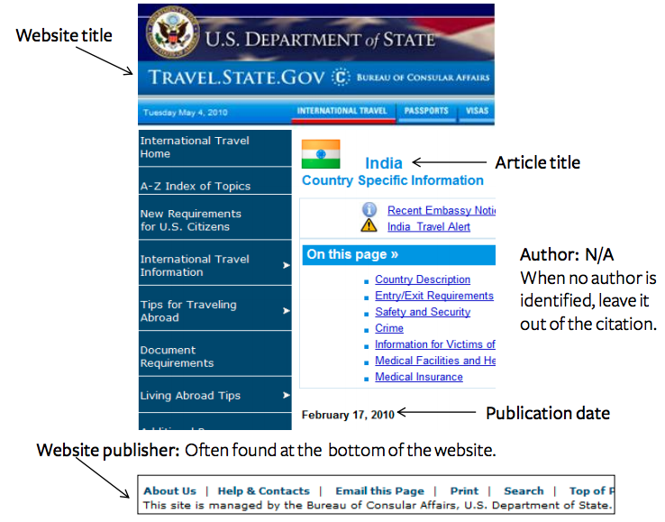
Date Accessed: This is the day the article was read and found.
Example:
“India.” Travel.State.Gov. Bureau of Consular Affairs, U.S. Department of State, 17 Feb. 2010. Web. 4 May 2010.

